**Machine Learning Models Deployment with IBM Cloud Watson Studio**

**PROBLEM STATEMENT:**

Become a wizard of predictive analytics with IBM Cloud Watson Studio. Train machine learning models to predict outcomes in real time. Deploy the models as web services and integrate them into your applications. Unlock the magic of data-driven insights and make informed decisions like never before!

**PROJECT TITLE:**

**Machine Learning Model Deployment for Student Dropout Analysis with IBM Cloud Watson Studio**

**PROBLEM DEFINITION:**

Student dropout rates in educational institutions have become a significant concern. Institutions invest substantial resources in nurturing students' potential, and when students drop out, it not only affects their futures but also leads to the underutilization of educational resources. The problem we aim to address is:

**PHASE 3 - PROJECT DEVELOPMENT PART-1**

* Uploading the Dataset
* Dataset cleansing
* Exploratory data analysis

**PROJECT DEVELOPMENT PART-2**

* Model selection

**FINAL PHASE OF THE PROJECT**

* Deployment of the model in IBM Cloud Watson Studio

**LINK TO THE DATASET**

https://docs.google.com/spreadsheets/d/1yg9IjaccCUlX347lQQGEYqVblfFMq8ITA4U_HbfGv4/edit?usp=sharing

**ABOUT THE DATASET:**

This dataset offers a comprehensive perspective on students enrolled in diverse  undergraduate programs provided by a higher education institution. It  encompasses a wide array of information, including demographic details,  socioeconomic factors, and academic performance metrics. The dataset is  instrumental in conducting an analysis to identify potential predictors of  student attrition and academic achievement.

The dataset is divided into multiple separate databases, each containing  pertinent information recorded at the time of enrollment. This information  includes details such as the application mode, marital status, chosen courses,  and more. Furthermore, the dataset enables the assessment of students' overall  performance at the end of each semester, considering factors like the curricular  units they completed, enrolled in, evaluated, or had approved, along with the  corresponding grades.

In addition to academic data, the dataset also provides economic indicators,  such as the unemployment rate, inflation rate, and regional GDP. These  economic factors contribute to a holistic understanding of how they might  influence student attrition rates and academic outcomes.

This dataset is a valuable analytical tool, offering insights into the factors that  motivate students to persist in their studies or discontinue their educational  pursuits across a diverse range of academic disciplines, including agronomy,  design, education, nursing, journalism, management, social  services, and technology.

**PROJECT DEVELOPMENT PART-2 : MODEL SELECTION**

**MODELING:**

In the predictive analytics journey, modeling emerges as a pivotal phase. Here, the dataset undergoes a dynamic exploration with the application of diverse machine learning algorithms. Each algorithm, distinguished by its unique strengths and weaknesses, is meticulously trained and tested to gauge its accuracy and efficacy in forecasting student dropout.

Here, we will train various models and then look for their accuracy.

**Logistic Regeression:**

**STRENGTHS: Simplicity**: Logistic Regression is straightforward and easy to implement. It doesn't require complex computations, making it an excellent choice for quick initial analyses.

**Interpretability:** The results are easily interpretable. The coefficients represent the change in the log-odds of the dependent variable for a one-unit change in the predictor variable. This makes it simple to understand the impact of each feature.

**WEAKNESSES:** **Limited to Linear Relationships**: Logistic Regression assumes a linear relationship between the independent variables and the log-odds of the dependent variable. This limitation means it might not perform well when the true relationship is highly non-linear.

**Complex Non-linear Relationships:** Logistic Regression struggles to capture complex non-linear relationships in the data. If the decision boundary (the line that separates different classes) is highly non-linear, Logistic Regression may not model it accurately.

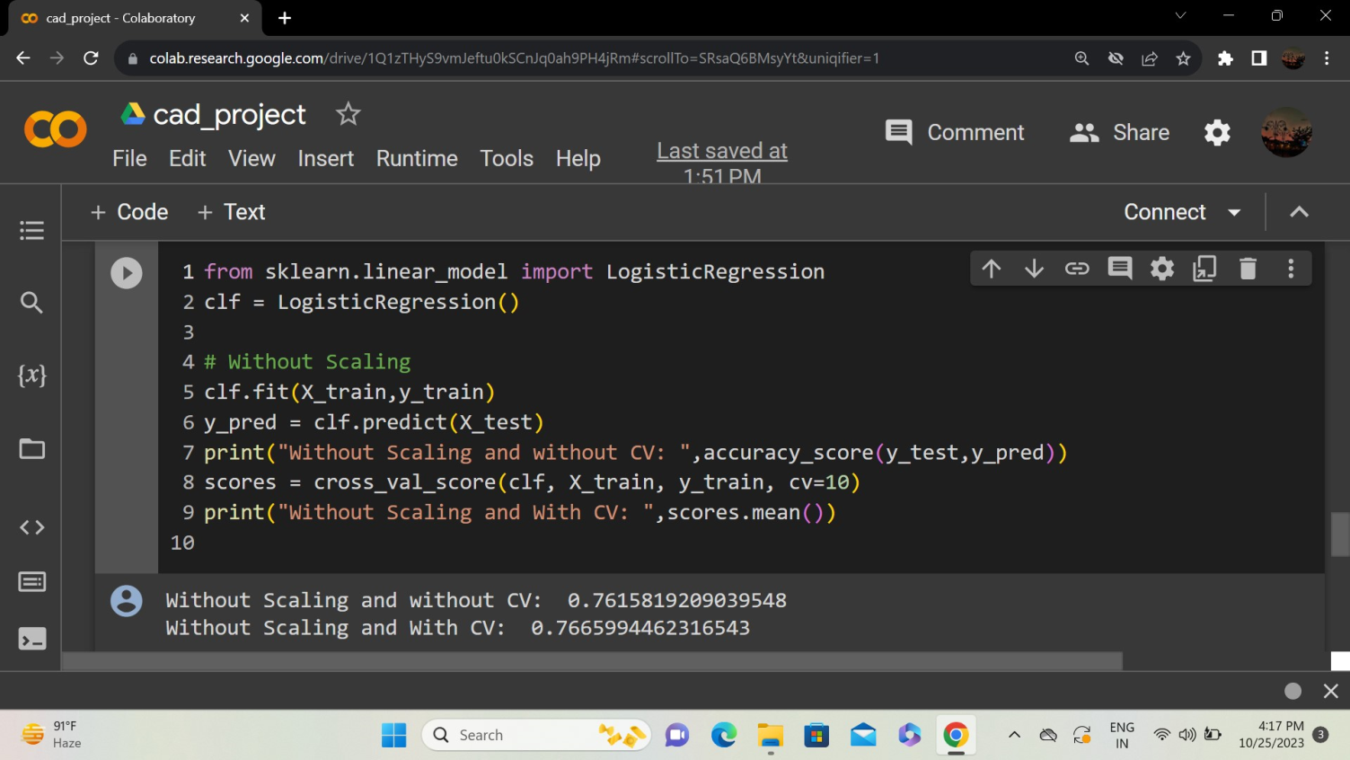

**Stochastic Gradient Classifier**

Stochastic Gradient Descent (SGD):

SGD is an optimization algorithm used to minimize the cost (or loss) function during the training of a machine learning model. It's particularly useful for large datasets because it updates the model parameters using only a subset of the training data at each iteration, rather than the entire dataset. This makes it computationally more efficient and allows the model to be updated more frequently.

Here's a brief overview of how SGD works:

Random Subset (Mini-Batch): Instead of using the full training dataset, SGD selects a random subset (mini-batch) of data for each iteration of the optimization.

Gradient Calculation: It calculates the gradient of the cost function with respect to the model parameters using the selected mini-batch.

Update Parameters: The model parameters are then updated in the opposite direction of the gradient, scaled by a learning rate.Iteration: Steps 1-3 are repeated for multiple iterations or until a stopping criterion is met.

SGD is commonly used in training neural networks, logistic regression, and other machine learning models. The term "stochastic" refers to the random sampling of data points for each iteration.

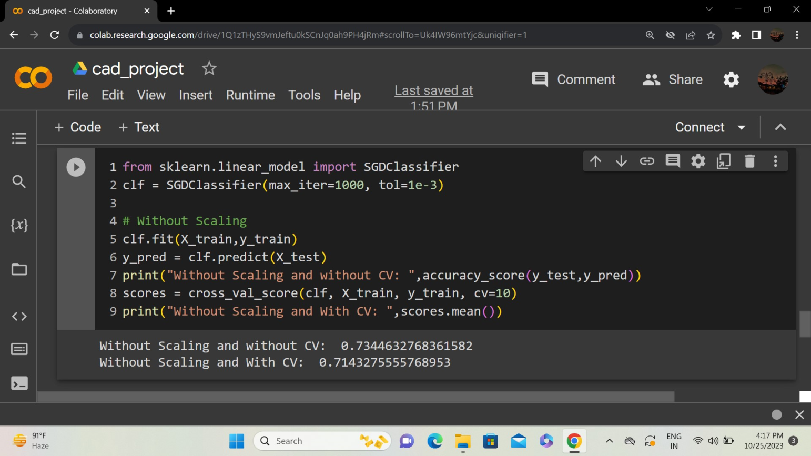

**PERCEPTRON:**

A perceptron is a type of artificial neuron that takes one or more binary inputs (0 or 1), applies weights to these inputs, sums them up, and then passes the result through an activation function to produce an output (usually 0 or 1). The purpose of the perceptron is to make binary decisions, making it a basic building block for more sophisticated machine learning models.

**Components:**

**Inputs**: The perceptron takes binary inputs, which can be considered as features in a machine learning context. Each input is associated with a weight.

**Weights:** Each input is multiplied by a weight. The weights determine the strength of the influence of each input on the perceptron's output. A higher weight amplifies the importance of the corresponding input.

**Summation:** The weighted inputs are summed up.

**Activation Function:** The sum is then passed through an activation function, which introduces non-linearity to the model. The activation function determines the output of the perceptron based on the summed inputs.

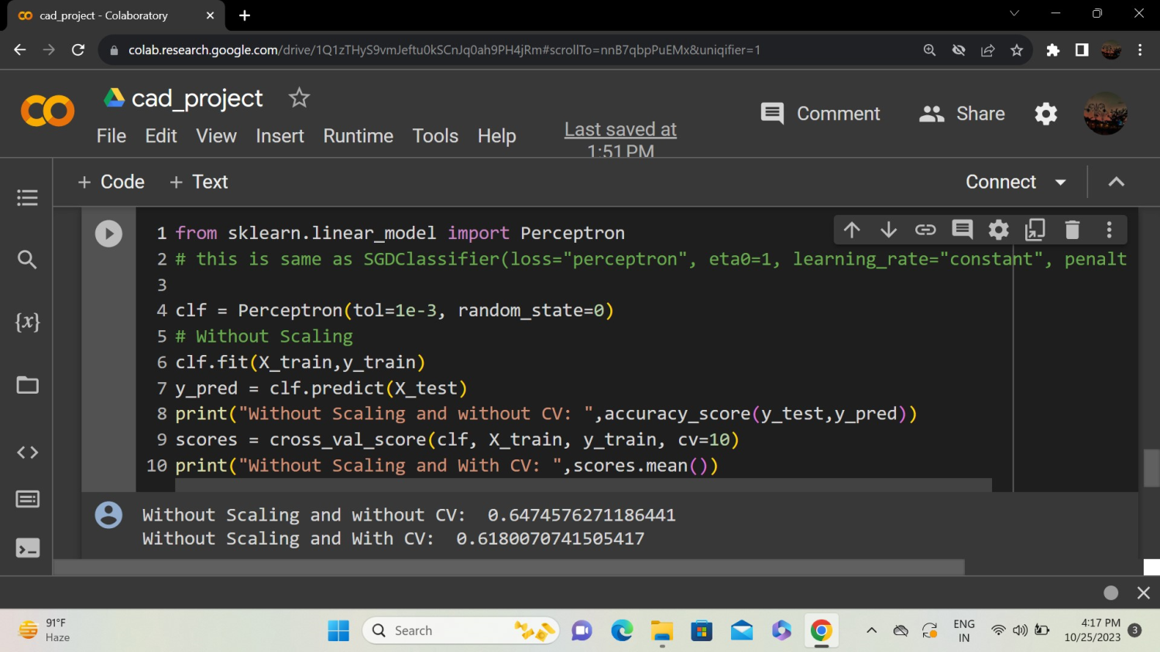**Output:** The output of the perceptron is the result of the activation function. In many cases, a threshold is used, and if the sum is above the threshold, the output is 1; otherwise, it's 0.

**Logistic Regression CV:**

Logistic Regression with Cross-Validation (Logistic Regression CV) is a variant of logistic regression that incorporates cross-validation during the training process. Cross-validation is a technique used to assess how well a model generalizes to an independent dataset. In the context of logistic regression, cross-validation helps to ensure that the model's performance is robust and not overly influenced by the specific split of the training and testing data.

**Data Splitting**: The dataset is divided into multiple folds (typically k folds) while maintaining the distribution of the target variable. Each fold serves as a validation set, and the remaining folds are used for training.

**Model Training:** Logistic Regression is trained on k-1 folds of the data.

**Model Validation:** The trained model is validated on the remaining fold to assess its performance.

**Cross-Validation Loop:** Steps 2 and 3 are repeated k times, with each fold being used as the validation set exactly once.

**Performance Metrics:** The performance metrics (e.g., accuracy, precision, recall) are averaged over the k iterations to obtain a more reliable estimate of the model's performance.

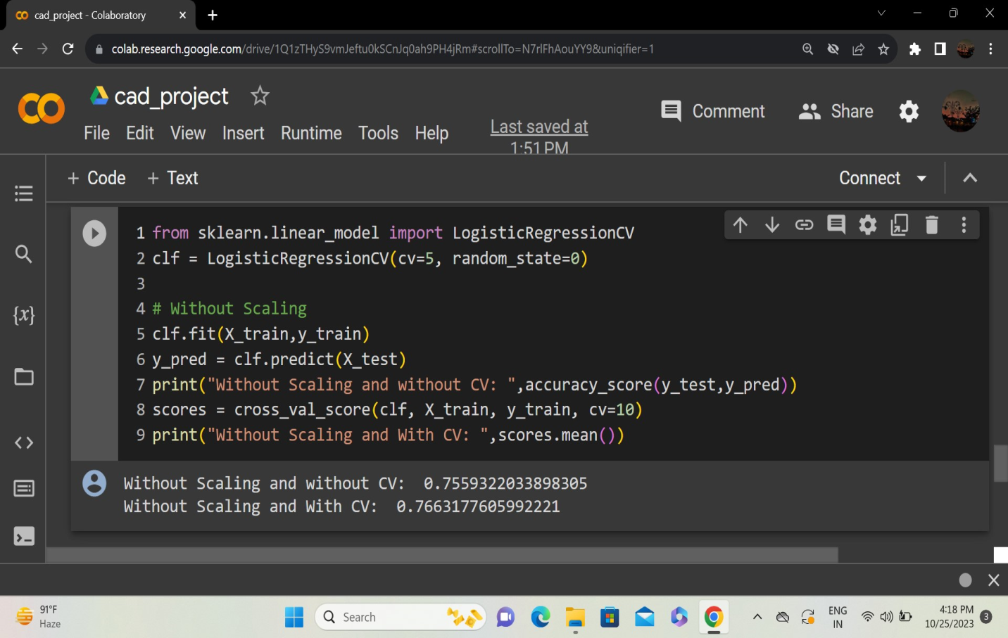

**Decision Tree Classifier:**

It is a supervised machine learning algorithm used for both classification and regression tasks. In the context of classification, it makes decisions based on the input features to assign a label to each data point. The decision-making process is represented as a tree structure where each node corresponds to a decision based on a feature, each branch represents the outcome of the decision, and each leaf node represents the final class label.

**Decision Nodes:** Each decision node in the tree corresponds to a test on an attribute (feature). The decision is based on whether the feature value for a data point satisfies a certain condition.

**Branches:** The branches emanating from a decision node represent the possible outcomes of the test. For example, if the condition is satisfied, the left branch might be taken; otherwise, the right branch is taken.

**Leaf Nodes**: The leaf nodes of the tree represent the class labels or, in the case of regression, a numerical value assigned to the data point.

**Decision-Making Process:** Starting from the root node, the algorithm traverses down the tree by making decisions at each node based on the feature values. The process continues until a leaf node is reached, and the corresponding class label is assigned.

**Training:** During the training phase, the algorithm learns the optimal decision rules by recursively splitting the dataset based on the features that best separate the classes.

Decision Trees are known for their interpretability and ease of understanding. However, they can be prone to overfitting, especially if the tree is allowed to grow deep. Techniques like pruning and limiting the tree depth can help mitigate overfitting.

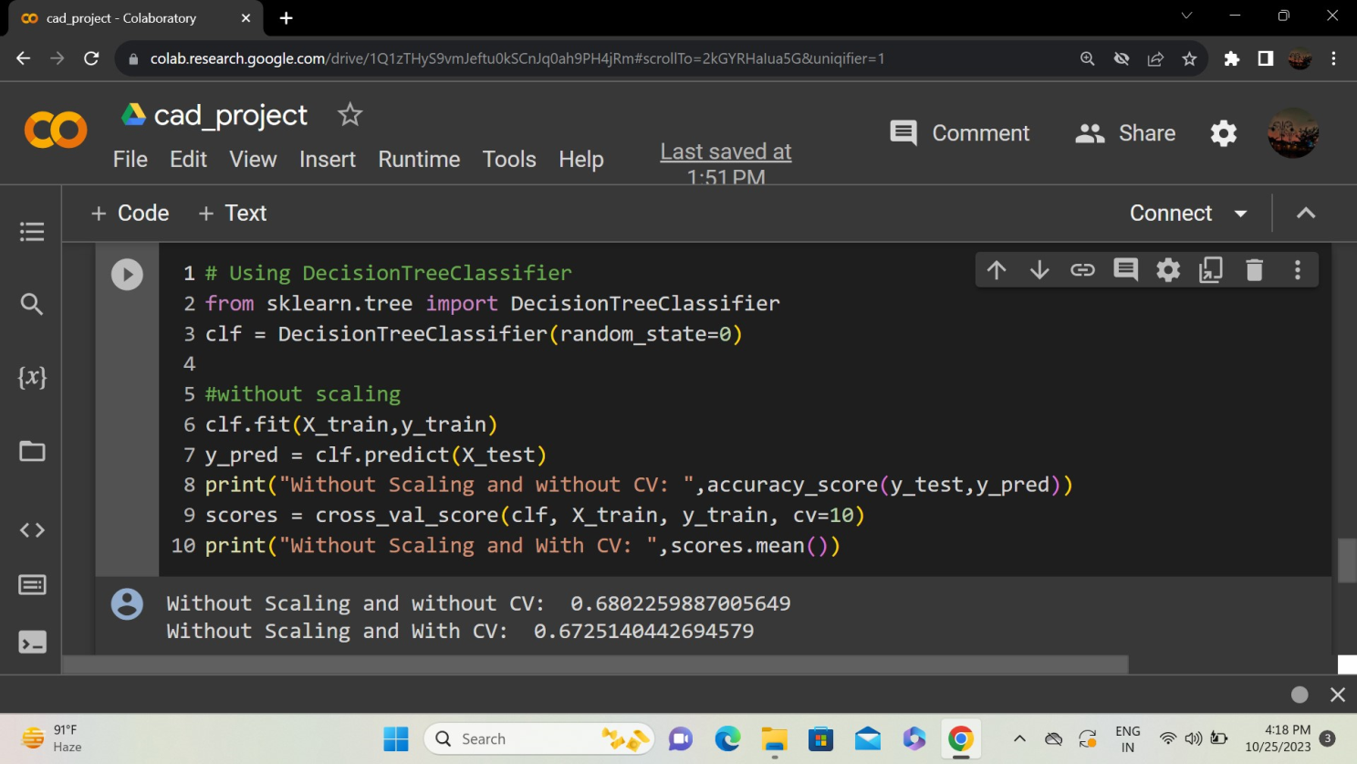

**Random Forest Classifier:**

It is an ensemble learning method based on the principle of constructing a multitude of decision trees at training time and outputting the class that is the mode of the classes (classification) or mean prediction (regression) of the individual trees. It is a versatile and powerful algorithm that provides better generalization and robustness compared to individual decision trees.

**Bootstrapped Sampling:** Random Forest starts by creating multiple bootstrap samples (random samples with replacement) from the original dataset. These samples are used to train individual decision trees.

**Random Feature Selection:** For each tree, a random subset of features is selected at each node during the training process. This introduces diversity among the trees, making the Random Forest less prone to overfitting.

**Decision Trees:** A decision tree is built for each bootstrap sample using the selected features. The tree-building process involves recursively splitting nodes based on the best feature and value to minimize impurity (e.g., Gini impurity for classification).

**Voting (Classification) or Averaging (Regression):** For classification tasks, the mode (most frequent class) among the predictions of individual trees is taken as the final prediction. For regression tasks, the mean prediction across all trees is calculated.

**Ensemble Effect:** The strength of Random Forest comes from the ensemble effect, where the combination of multiple weak learners (individual decision trees) results in a strong learner with improved generalization.

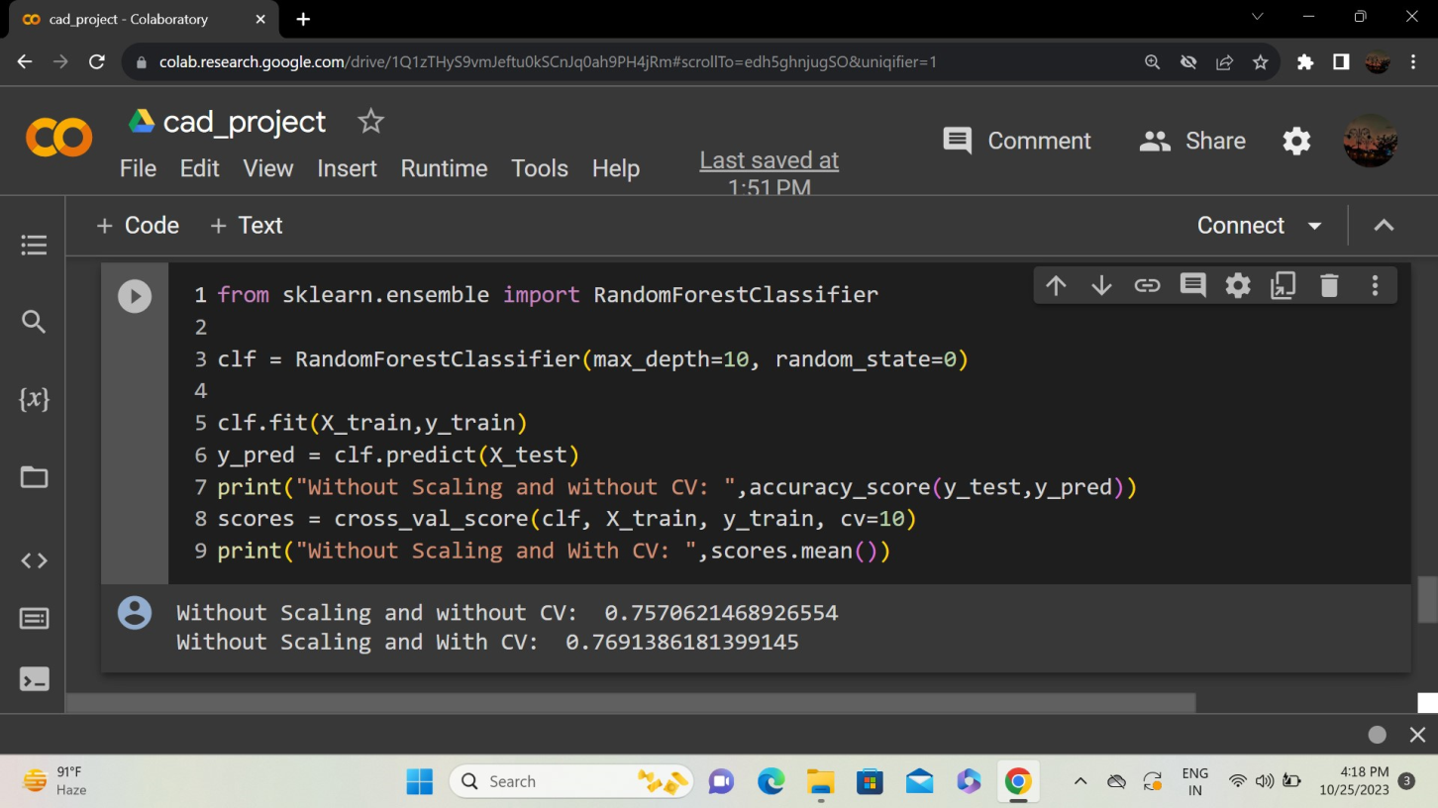

**Support Vector Machine:**

A Support Vector Machine (SVM) is a supervised machine learning algorithm that can be used for both classification and regression tasks. It works by finding the optimal hyperplane that separates data points of different classes in a high-dimensional space. SVM is particularly effective in scenarios where the data is not linearly separable in the original feature space. It achieves this by mapping the input features into a higher-dimensional space using a kernel function.

**Linear Separation:** In a binary classification problem, SVM aims to find a hyperplane that best separates the data into two classes. This hyperplane is chosen to maximize the margin, which is the distance between the hyperplane and the nearest data point of each class.

**Support Vectors**: Support Vectors are the data points that are closest to the decision boundary (hyperplane). These points play a crucial role in determining the optimal hyperplane and are used to define the margin.

**Margin:** The margin is the distance between the decision boundary and the nearest data point of either class. SVM aims to maximize this margin, as it improves the model's ability to generalize to new, unseen data.

**Non-linear Separation:** SVM can handle non-linear separation by using kernel functions. These functions implicitly map the input features into a higher-dimensional space, making it possible to find a hyperplane that separates the data even when it's not linearly separable in the original feature space.

**Kernel Trick**: The kernel trick allows SVM to efficiently compute the dot product of data points in the higher-dimensional space without explicitly calculating the transformation. Common kernel functions include linear, polynomial, radial basis function (RBF), and sigmoid.

**C Parameter:** The C parameter in SVM controls the trade-off between achieving a smooth decision boundary and classifying training points correctly. A smaller C encourages a larger margin but may allow some training points to be misclassified, while a larger C makes the model prioritize classifying all training points correctly.

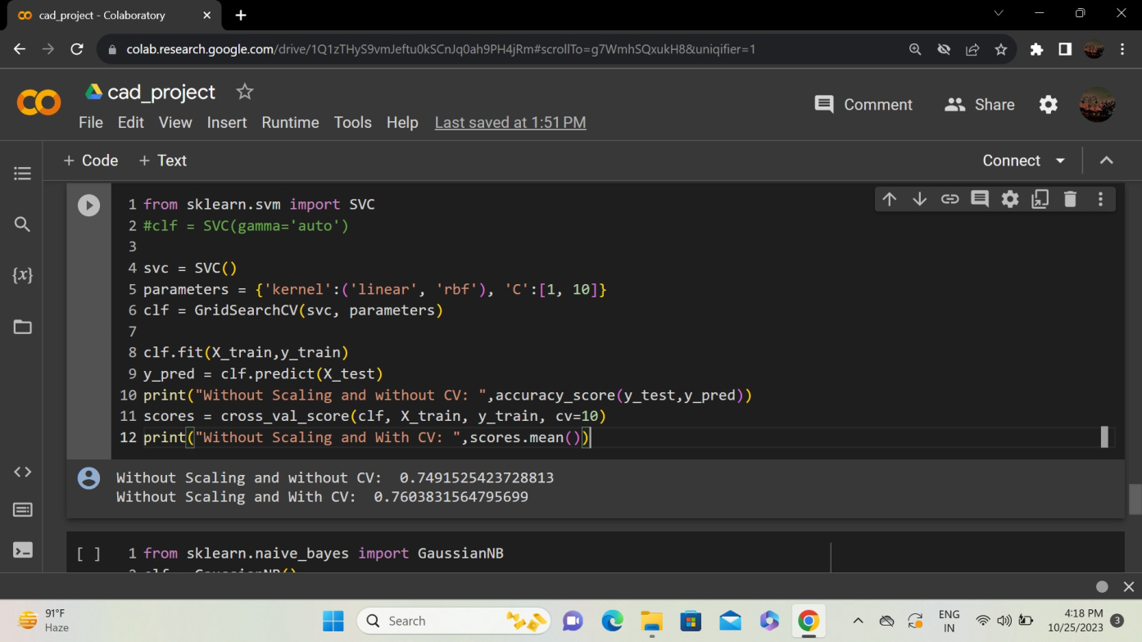

**Naive Bayes**

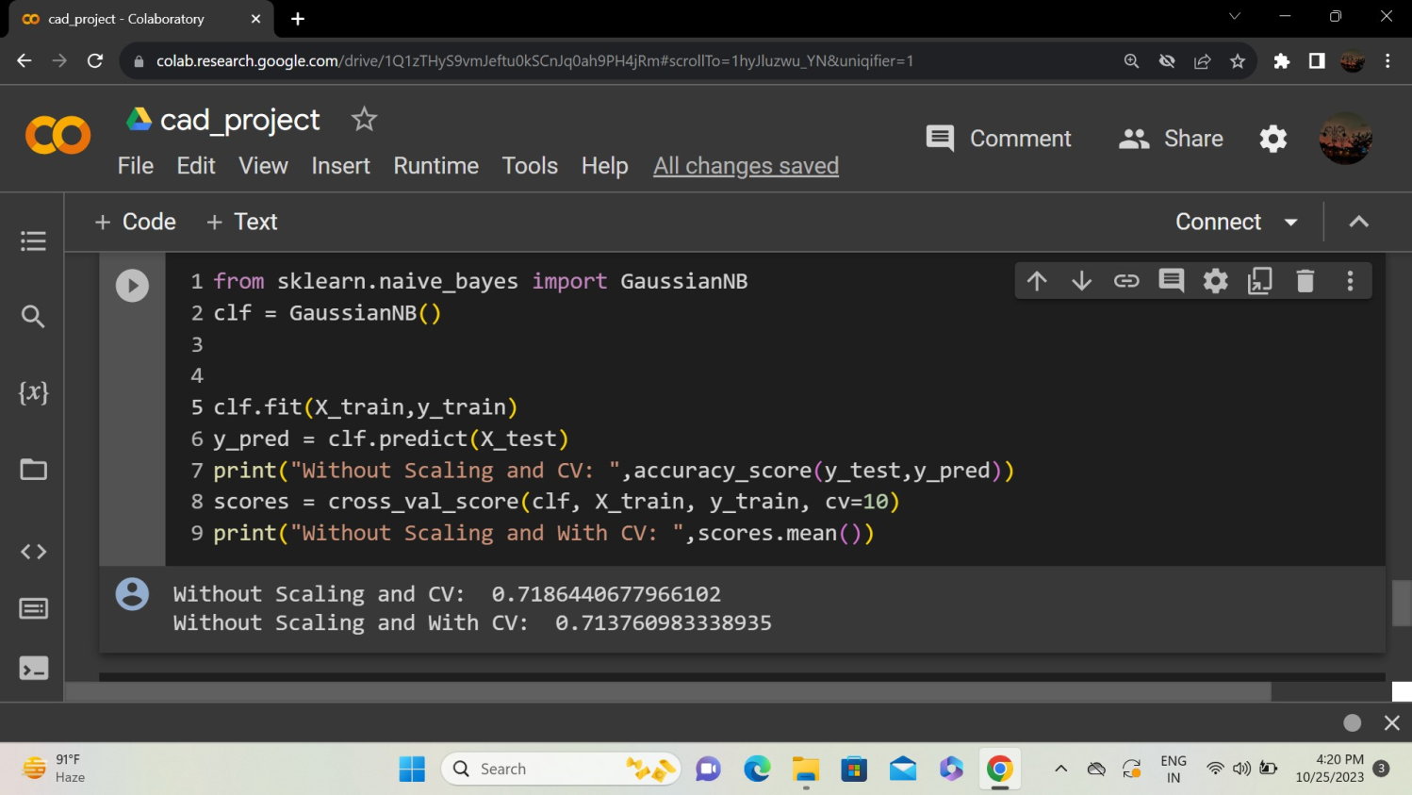

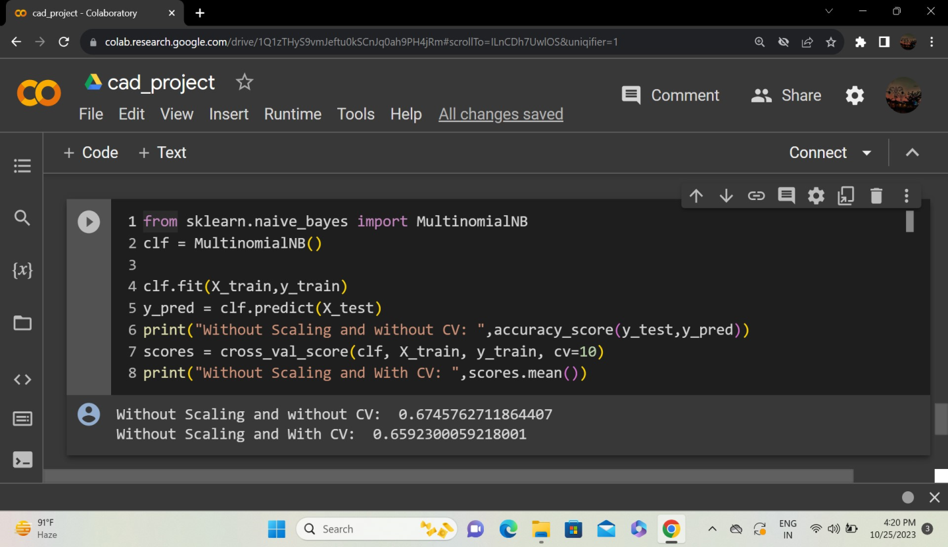

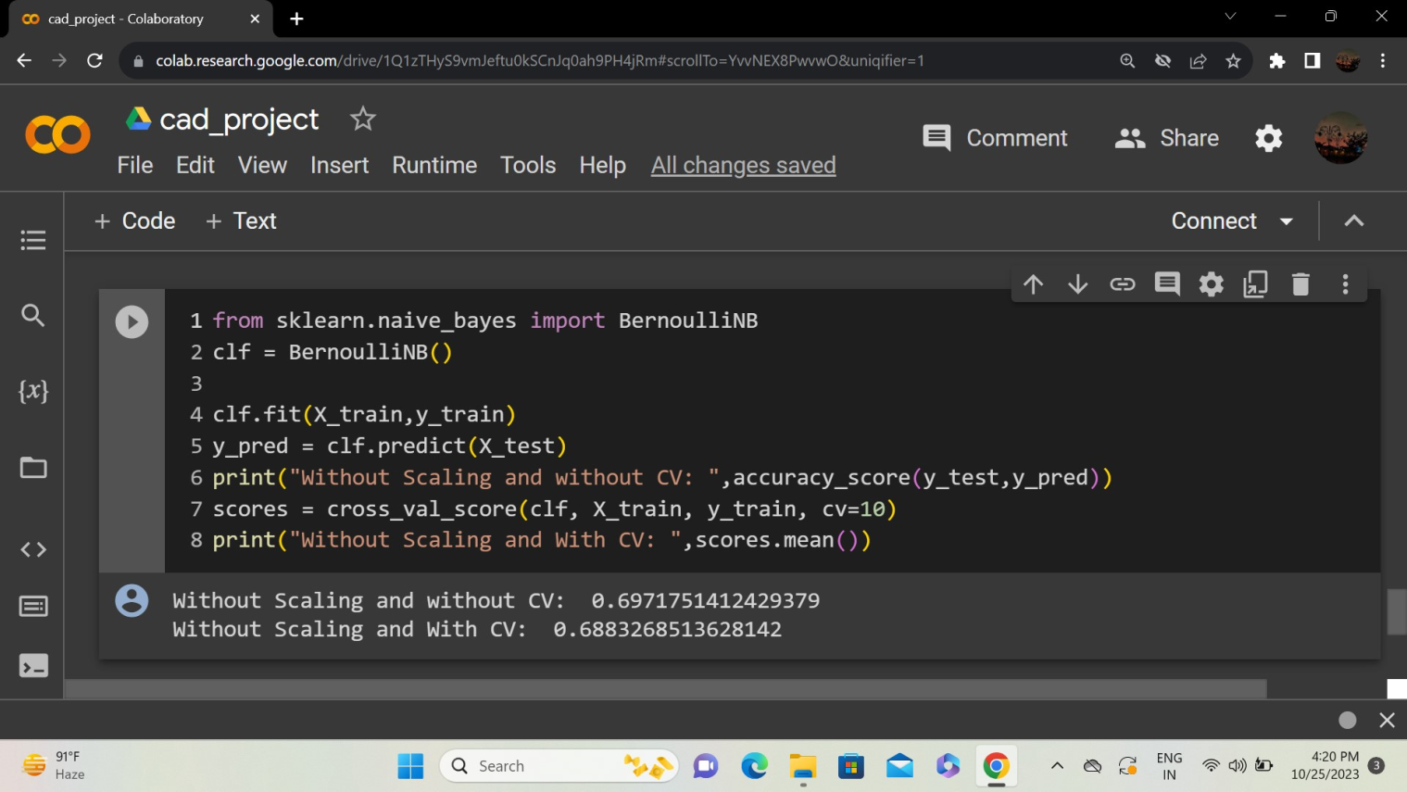

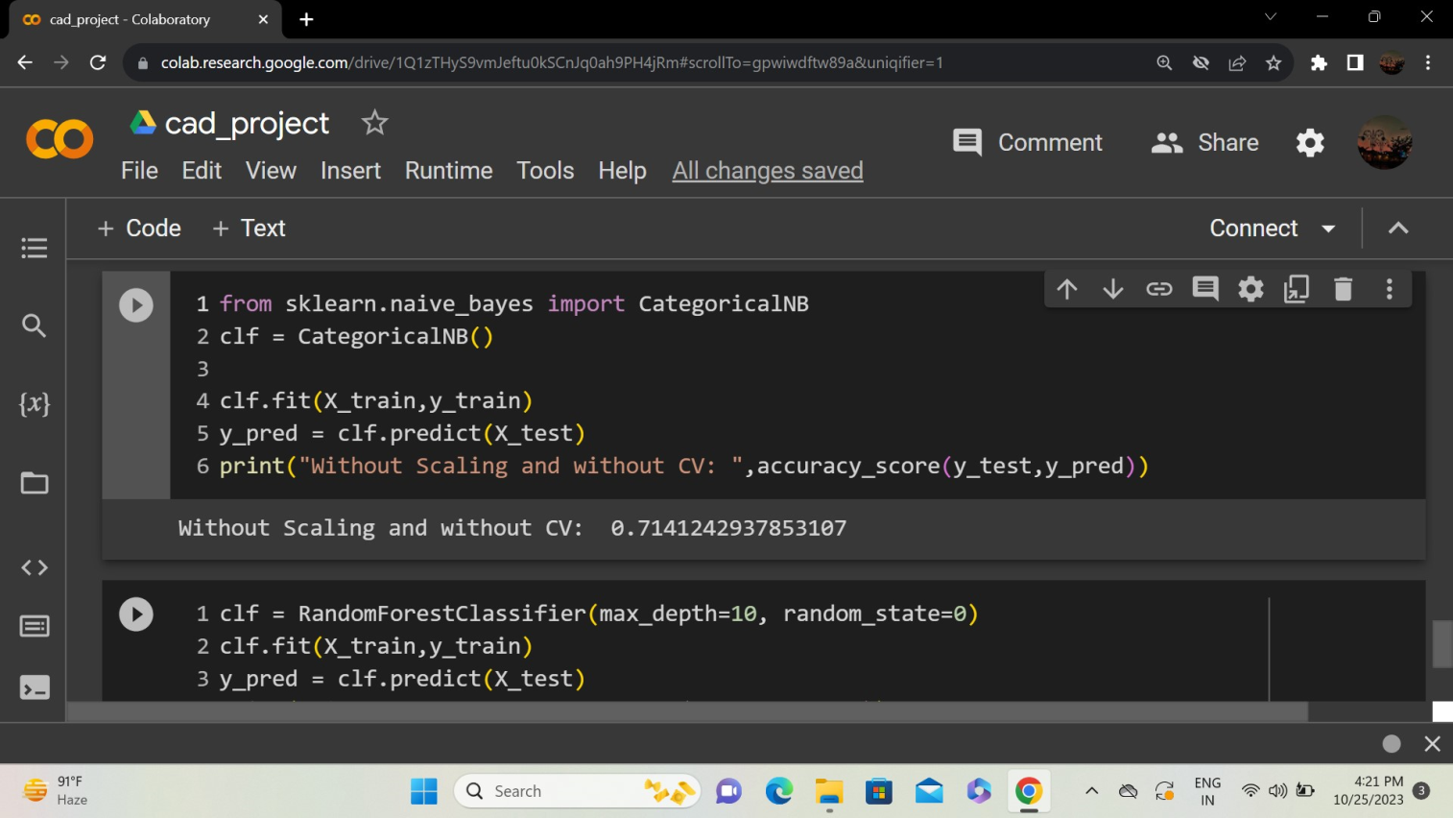

**K-Nearest Neighbors (KNN):**

The K-Nearest Neighbors (KNN) algorithm is a versatile and simple machine learning algorithm used for both classification and regression tasks. In the context of classification, it assigns a data point to the majority class among its k-nearest neighbors. The distance metric (such as Euclidean distance) is used to measure proximity.

Parameter k: The number of neighbors (k) is a crucial parameter in KNN. It determines how many neighboring data points influence the classification of a new data point.

Distance Metric: The choice of distance metric (e.g., Euclidean distance, Manhattan distance, etc.) influences how proximity is measured between data points.

Voting Mechanism: For classification, KNN uses a majority voting mechanism. The class that is most common among the k-nearest neighbors is assigned to the new data point.

Regression in KNN: In regression tasks, the predicted value for a new data point is the average of the values of its k-nearest neighbors.

Scaling Features: It's often beneficial to scale features before applying KNN to prevent features with larger scales from dominating the distance calculation.

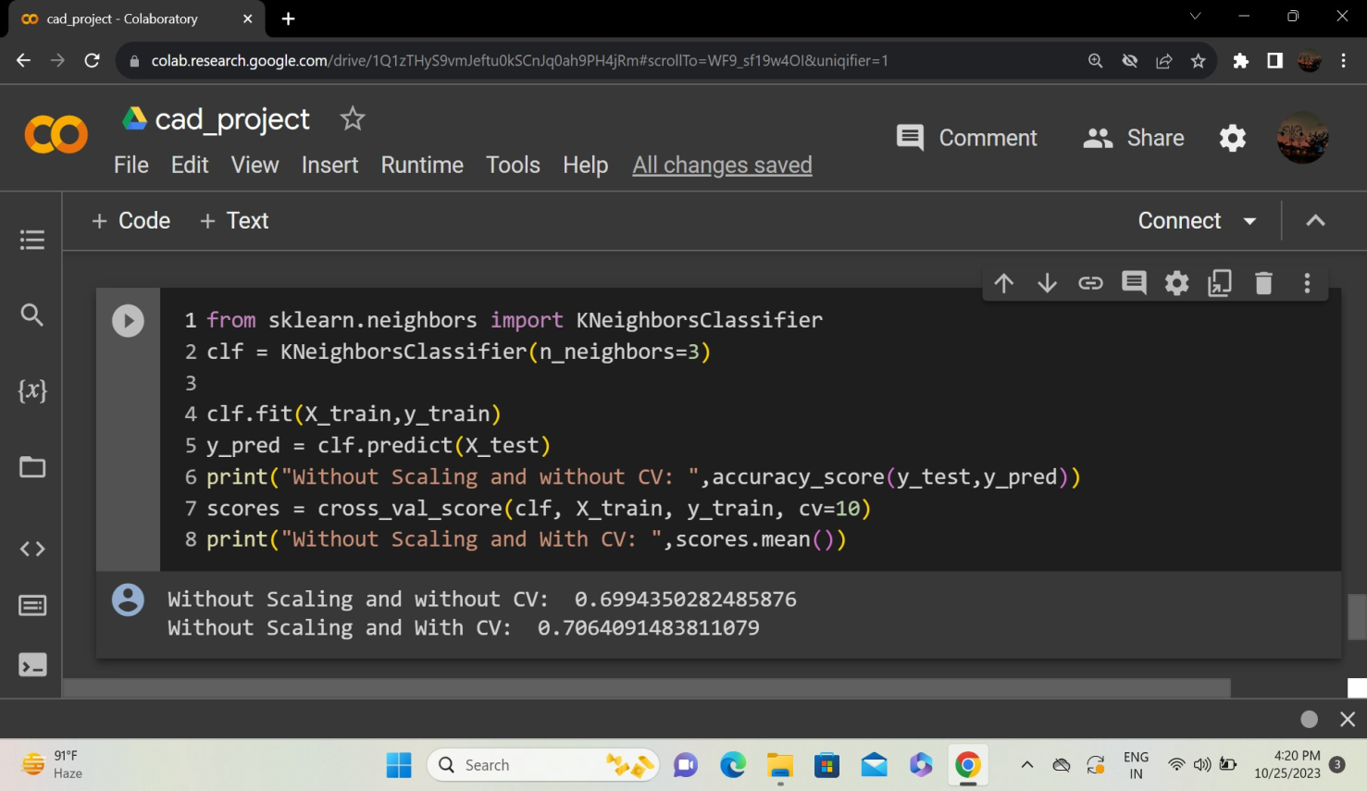

**Model Selection:**

